**WEB BROWSER IN PYTHON**

**Introduction:**

In this report, we will discuss a simple web browser program written in Python. The program uses the tkinter module for the user interface and the webbrowser module for web navigation. The program allows the user to enter a URL in a text box and opens that URL in the default web browser when the user clicks the "Go" button. The program also includes additional functionality such as a background image, larger text box and button, and the use of the Python Imaging Library (PIL) package.

**Required Packages:**

The following packages are required to run the program:

* tkinter: The tkinter module is part of the Python standard library and provides a set of tools for creating graphical user interfaces (GUIs) in Python.
* webbrowser: The webbrowser module is also part of the Python standard library and provides a simple way to open URLs in the default web browser.
* Pillow: The Pillow package is a fork of the original Python Imaging Library (PIL) package and provides a wide array of image processing capabilities. It is used in this program to open and resize the background image.

**Algorithm:**

The program uses the following algorithm:

* Import the necessary modules (tkinter, webbrowser, and PIL).
* Define a function open_url() that uses the webbrowser.open() function to open the URL entered in the text box.
* Create the main window using the tkinter Tk() class.
* Add a background image to the main window using the PIL Image and ImageTk classes.
* Create a text box for entering URLs using the tkinter Entry class.
* Create a "Go" button using the tkinter Button class, and set its command to the open_url() function.
* Start the main event loop using the mainloop() method.

**Sample Output:**

When the program is run, a window will appear with a background image and a text box for entering URLs. The user can enter a URL in the text box and click the "Go" button to open that URL in the default web browser. The window will look like this:

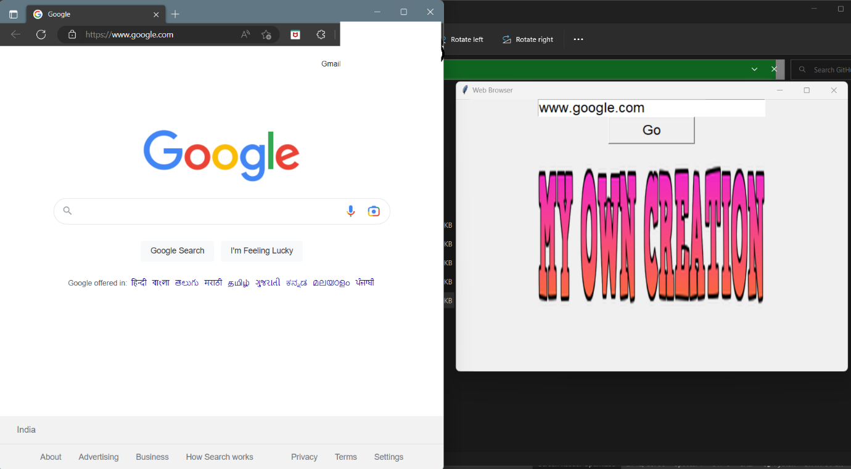

As the program is simple, the output will be the same as the input URL, which will be opened in the default browser.

**Conclusion:**

In this report, we have discussed a simple web browser program written in Python using the tkinter and webbrowser modules. The program allows the user to enter a URL in a text box and opens that URL in the default web browser when the user clicks the "Go" button. We also discussed the use of the Python Imaging Library (PIL) package to add a background image to the program. This program serves as a basic example of how to create a web browser using Python and can be further modified to include more advanced functionality.